I) Programs based on Basic Concepts:
- WAP to calculate area of circle.
import java.util.Scanner; // to import scanner class

class Circle_area{
public static void main(String args[]){
Scanner myObj = new Scanner(System.in); // Create Scanner oject
System.out.print("Enter radius of the circle: ");
double area;
double radius = myObj.nextDouble(); // Read user input
area = 3.14*(radius*radius);
System.out.println(" area of the enter radius circle is : " + area);
}

}
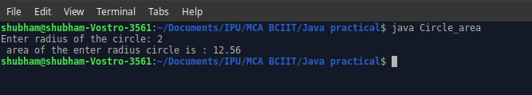

- WAP to calculate average marks of a student by taking marks in 5 subjects.
import java.util.Scanner;

class Average_marks{
public static void main(String args[]){
Scanner myObj = new Scanner(System.in);
System.out.println("Enter 5 subject marks");

System.out.print("\n Enter marks in Enlish: ");
double eng = myObj.nextDouble();

System.out.print("\n Enter marks in Maths: ");
double mat = myObj.nextDouble();

System.out.print("\n Enter marks in Science: ");
double sci = myObj.nextDouble();

System.out.print("\n Enter marks in Hindi: ");
double hin = myObj.nextDouble();

System.out.print("\n Enter marks in SST: ");
double sst = myObj.nextDouble();

System.out.println("\n Total average marks: " + (eng + mat + sci + hin + sst )/5);
}
}
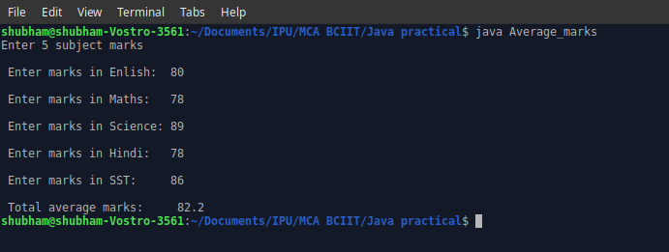

- WAP to print ASCII value of a character given as input by user.
import java.util.Scanner;

class Acsii{
public static void main(String args[]){
Scanner Obj = new Scanner(System.in);
System.out.print("\n Enter a Character :");
char c = Obj.next().charAt(0);
int a = c;
System.out.print("\n The ASCII Value of "+c+" : "+a+"\n");

}
}
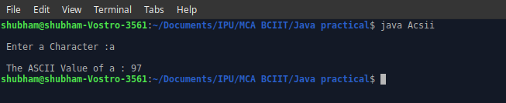

- WAP to find maximum of two numbers using conditional operator.
import java.util.Scanner;

class MaxNo{
public static void main(String args[]){
Scanner Obj = new Scanner(System.in);
System.out.print("\n Enter first No. : ");
double f1 = Obj.nextDouble();
System.out.print("\n Enter second No. : ");
double f2 = Obj.nextDouble();
double re;
re=(f1>f2)? f1:f2;
System.out.print("\n in between "+f1+" and "+f2+"\n "+re+" is Greater. \n" );

}
}
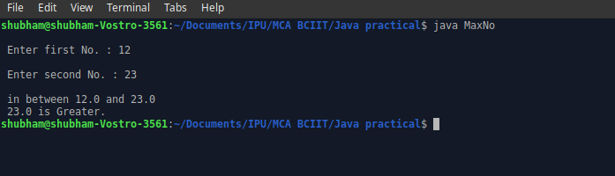

- WAP to find whether a number is positive or not using conditional
Operator.
import java.util.Scanner;

class PositiveNo{
public static void main(String args[]){
Scanner O = new Scanner(System.in);
System.out.print("\n Enter a Number : ");
double n1 = O.nextDouble();
char ch;
ch=(n1>=0)?'+':'-';
System.out.print("\n Enter Number "+n1+" is "+ch+" ve Number \n");
}
}
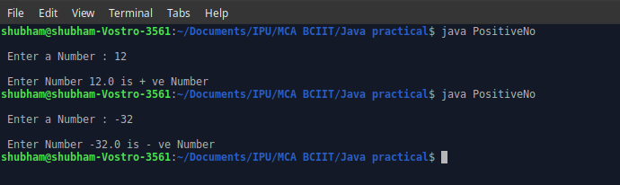

6. WAP to swap two numbers with and without using third variable.
Using third variable
import java.util.Scanner;

class Swap_Three_Var{
public static void main(String args[]){
Scanner O = new Scanner(System.in);
System.out.print("\n Enter first variable :");
double f1 = O.nextDouble();
System.out.print("\n Enter second variable :");
double f2 = O.nextDouble();
double f3;
System.out.print("\n First variable : "+f1+" and Second variable :"+f2);
f3=f1;
f1=f2;
f2=f3;
System.out.print("\n\t\t\t After Swap \n First variable : "+f1+" and Second variable :"+f2+"\n");

}
}
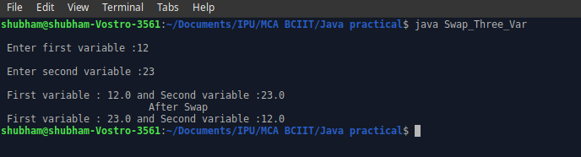

Using two variable
import java.util.Scanner;

class Swap_Two_Var{
public static void main(String args[]){
Scanner O = new Scanner(System.in);
System.out.print("\n Enter first variable :");
double f1 = O.nextDouble();
System.out.print("\n Enter second variable :");
double f2 = O.nextDouble();

System.out.print("\n First variable : "+f1+" and Second variable :"+f2);
f1=f1+f2;
f2=f1-f2;
f1=f1-f2;
System.out.print("\n\t\t\t After Swap \n First variable : "+f1+" and Second variable :"+f2+"\n");

}
}
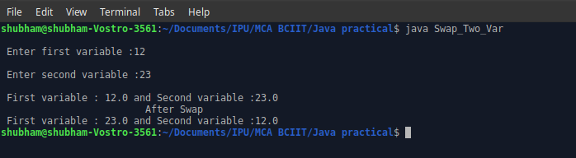

II) Programs based on Selection Statements:
If –Else
7. WAP to check number is even or odd with and without using modulus
Operator.

import java.util.Scanner;

class Odd_or_Even_Without_Mod{
public static void main(String args[]){
Scanner O = new Scanner(System.in);
System.out.print("\n Enter variable :");
double f1 = O.nextDouble();
while(f1>1)
{
f1=f1-2;

}
if(f1==1)
System.out.println(" Odd number");
else
System.out.println(" Even number");

}
}
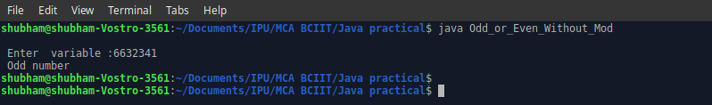

8. WAP to checked character entered is vowel or consonant.
import java.util.Scanner;

class Check_ch{
public static void main(String args[]){
Scanner O = new Scanner(System.in);
System.out.print("\n Enter a character : ");
char c = O.next().charAt(0);
if(c=='a'||c=='A'||c=='e'||c=='E'||c=='i'||c=='I'||c=='o'||c=='O'||c=='u'||c=='U')
System.out.println(c+" is Vowel"); // for vowel
else
System.out.println(c+" is Consonant"); // Consonant
}
}
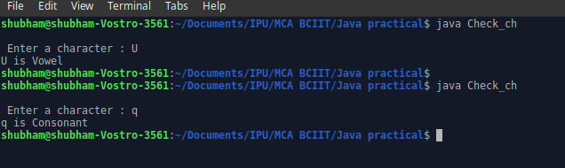

Nested If-Else
9. WAP to find maximum among three numbers.
import java.util.Scanner;

class Max_in_three{
public static void main(String args[]){
Scanner o = new Scanner(System.in);
int a,b,c;
System.out.print("\n Enter first no. : ");
a = o.nextInt();
System.out.print("\n Enter second no. : ");
b = o.nextInt();
System.out.print("\n Enter third no. : ");
c = o.nextInt();
if(a>b){
if(a>c)
System.out.println(a+" Greater among "+a+","+b+" & "+c);
else
System.out.println(c+" Greater among "+a+","+b+" & "+c);
}
else{
if(b>c)
System.out.println(b+" Greater among "+a+","+b+" & "+c);
else
System.out.println(c+" Greater among "+a+","+b+" & "+c);

}
}
}
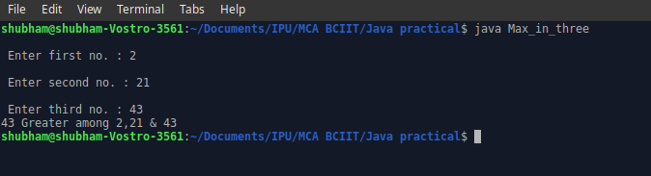

10. WAP to check a year is leap or not.
import java.util.Scanner;

class Leap_Year
{
public static void main(String args[])
{
Scanner O = new Scanner(System.in);
System.out.print("\n Enter a year :" );
int year = O.nextInt();
if(year%4==0){
if(year%100==0){
if(year%400==0){
System.out.println(year+" is leap year");
}
else
System.out.println(year+" is not leap year");
}
else
System.out.println(year+" is leap year");
}
else
System.out.println(year+" is not leap year");
}
}
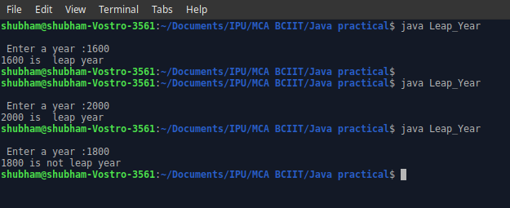

Else-If Ladder
11. WAP to print the message according to temperature entered by user.
T<=0----very cold
0<T<=10---cold
11<T<=20---cool
20<T<=30---warm
T>30---hot
import java.util.Scanner;
class Temperature_ELSE_IF_LADDER{
public static void main(String args[])
{
Scanner O = new Scanner(System.in);
System.out.print("\n Enter a temperature: ");
int T= O.nextInt();
if(T<=0)
System.out.println(" Very Cold: "+T);
else if(T>0 && T<=10)
System.out.println(" Cold: "+T);
else if(T>=11 && T<=20)
System.out.println(" Cool: "+T);
else if(T>20 && T<=30)
System.out.println(" Warm: "+T);
else if(T>30)
System.out.println(" Hot: "+T);
else
System.out.println(" Wrong Input");
}

}
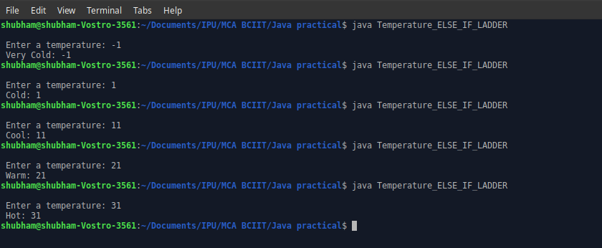

Switch statement
12. Create a menu driven program to implement arithmetic operations.
import java.util.Scanner;
class Arithematic_operation{
public static void main(String args[])
{
Scanner O = new Scanner(System.in);
System.out.print("\n Enter first no: ");
double a = O.nextDouble();
System.out.print("\n Enter second no: ");
double b = O.nextDouble();
System.out.print("\n Arithematic Operation Choice : \n 1. Add \n 2. Subtract \n 3. Divide \n 4. Multiply \n Your Choice: " );
int ch = O.nextInt();
double c;
switch(ch){
case 1:
c = a+b;
System.out.println(" Output of "+a+" + "+b+" = "+c);
break;

case 2:
c = a-b;
System.out.println(" Output of "+a+" - "+b+" = "+c);
break;

case 3:
c = a/b;
System.out.println(" Output of "+a+" / "+b+" = "+c);
break;

case 4:
c = a*b;
System.out.println(" Output of "+a+" X "+b+" = "+c);
break;

default:
System.out.println(" Wrong Choice ");
break;

}
}
}
